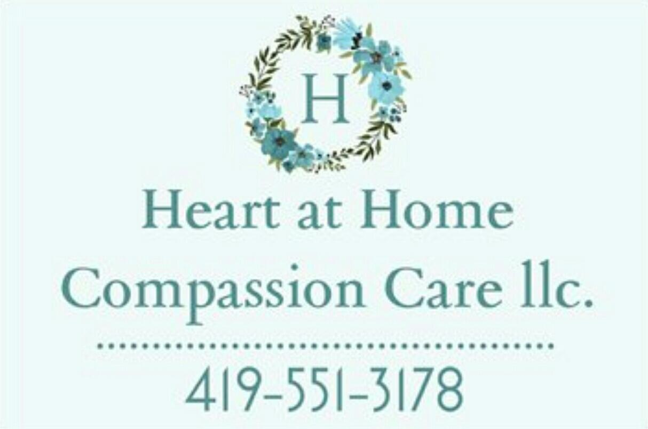

We are a local, non-medical, private pay, in-home Compassion Care Service established February 2017. Located at 12909 State Route 15 Suite A Montpelier, Ohio, we provide care 24/7/365 to clients in the Tri-State Area. Days, evenings, nights, weekends and holidays! We have a 3 hour shift minimum with rates starting as low as $25/hour (time plus one half on holidays) give us a call to see what we can do for you!

We understand there are only so many hours in the day; life gets the best of us all, every now and then we all need a little help.

Some things we offer include but are not limited to:

Local (within 30 miles) transportation, errands, shopping, making appointments, reminders to take medication, bathing, cleaning, cooking, as well as being of good company, talking, playing cards, or anything else that will keep the brain active.

We have two licensed massage therapists on board and for an additional fee, services can be provided in the comfort of your own home, or at our relaxing office setting. Our office setting offers Massage Therapy, Nail services and Skincare services as well.

You can contact us by telephone at 419-551-3178, or by email at [heartathomecc@outlook.com.](mailto:heartathomecc@outlook.com)

If you’d like to stay in touch and up to date with us, check us out on Facebook:

[Www.facebook.com/HeartAtHomeCompassionCareLLC](http://Www.facebook.com/HeartAtHomeCompassionCareLLC)